$55

7-9 pm

Salem Evangelical Church,

455 Locust St. NE Salem

<https://wvbahive.org> for complete details

Willamette Valley Beekeepers Association-Bee School 2023

February 6,13,20, 27, 2023 Salem Evangelical Church

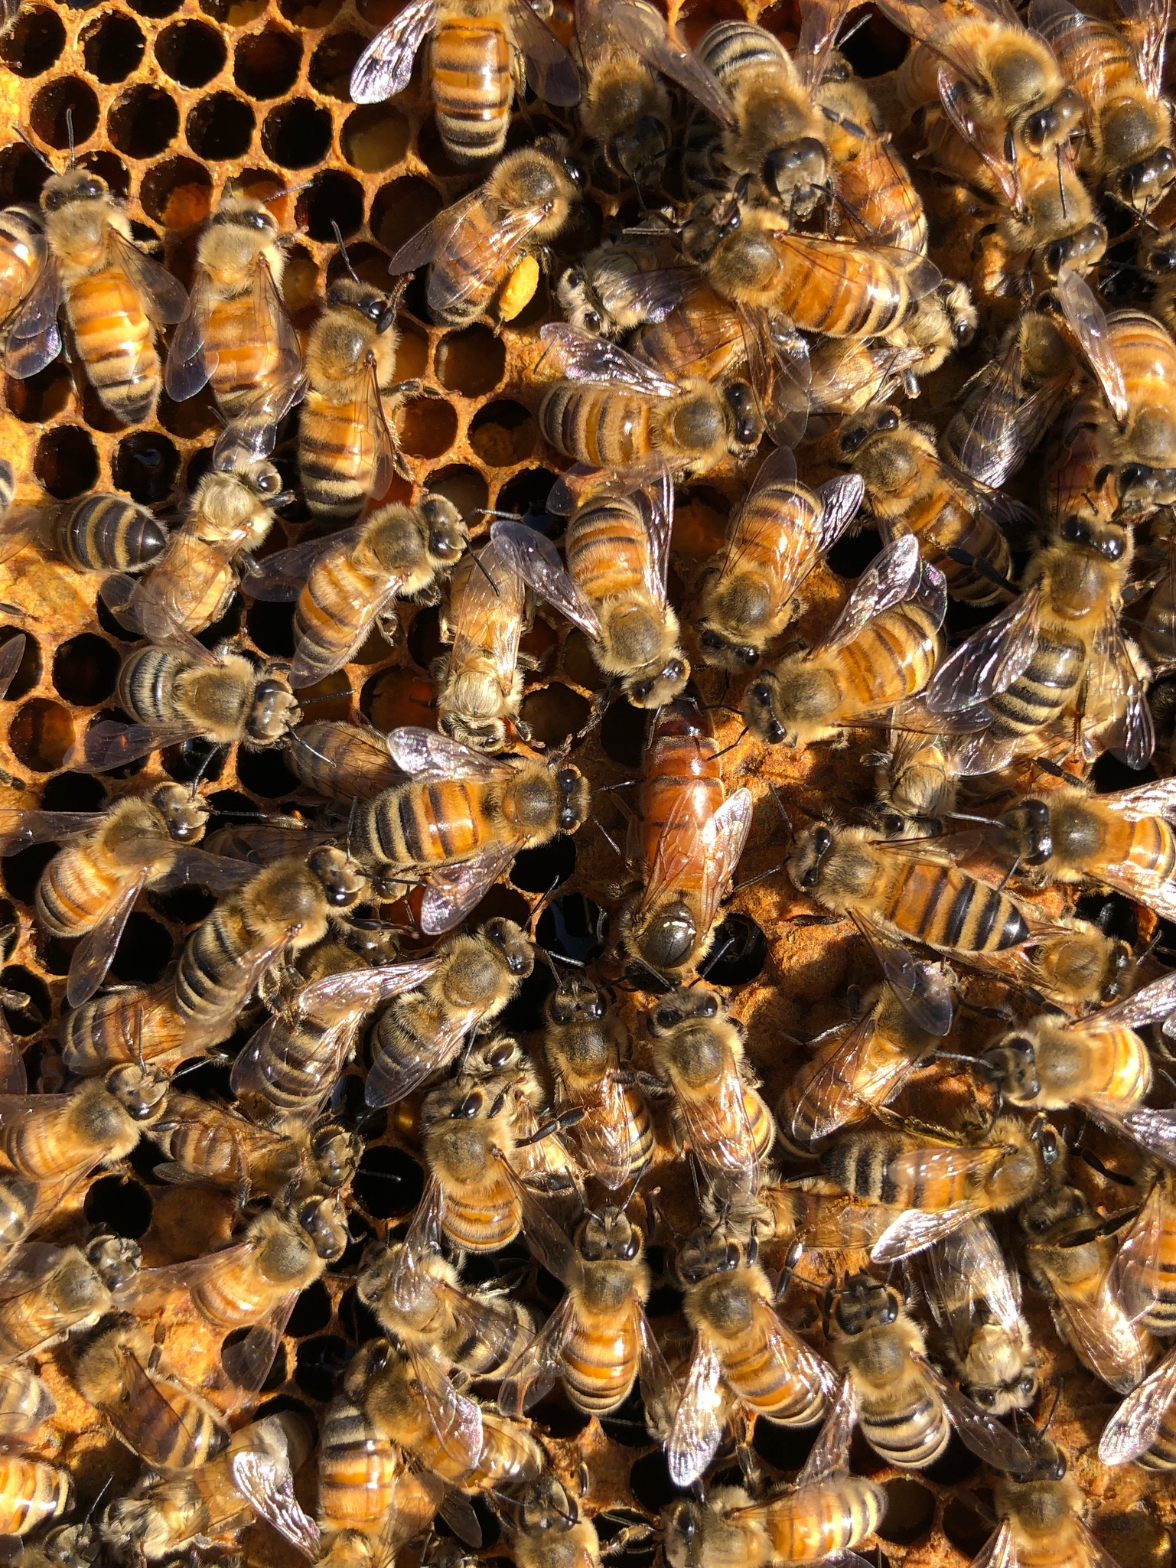

All Hail the Queen!